**Factors Affecting Project Success Rate**

* Project Size and Complexity
* Customer Satisfaction Level
* Development and Budget Process
* Skills of Developers and Managers

**Development Team**

* **Requirement analysts:** work with the customers to identify and document the requirements
* **Designers:** generate a system-level description of what the system is supposed to do
* **Programmers:** write lines of code to implement the design
* **Testers:** catch faults
* **Trainers:** show users how to use the system
* **Maintenance team:** fix faults that show up later
* **Librarians:** prepare and store documents such as software requirements
* **Configuration management team:** maintain correspondence among various artefacts

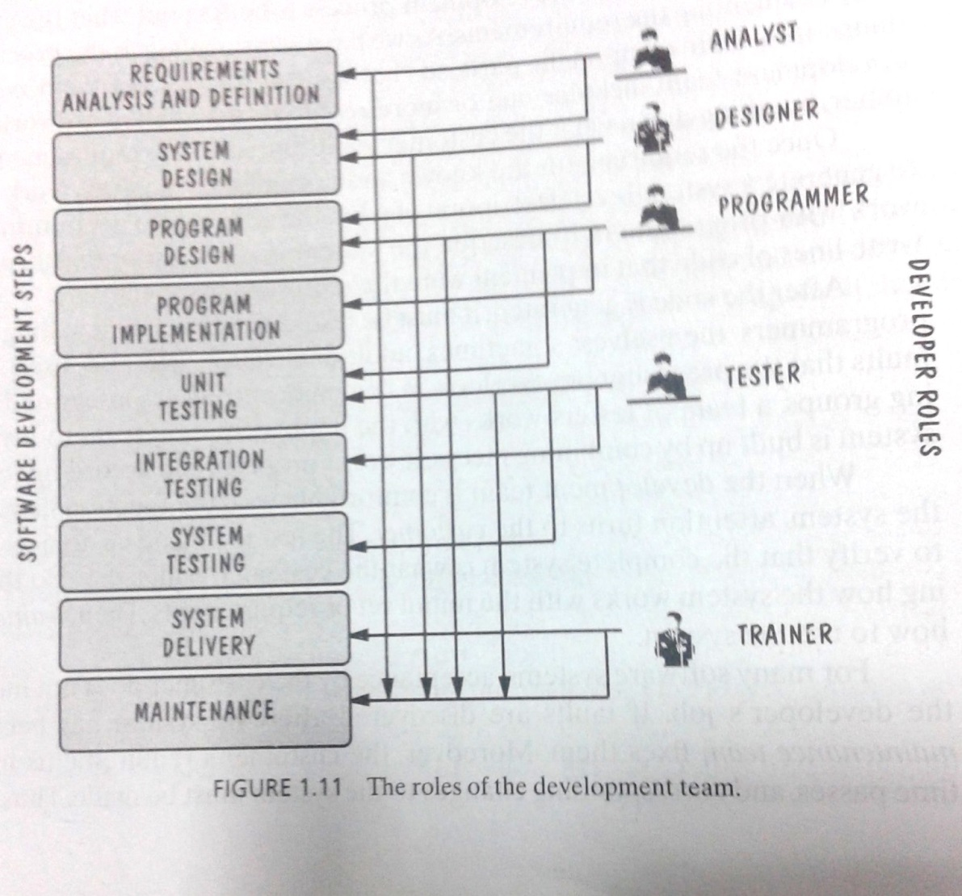

**Software Lifecycle**

* + Requirements analysis and definition
  + System (architecture) design
  + Program (detailed/procedural) design
  + Writing programs (coding/implementation)
  + Testing: unit, integration, system
  + System delivery (deployment)
  + Maintenance

**What is a Good Software Product? McCall's Quality Factors**

1. **Correctness**

The extent to which a software meets its requirements specification.

1. **Efficiency**

The amount of hardware resources and code the software, needs to perform a function.

1. **Integrity**

The extent to which the software can control an unauthorized person from the accessing the data or software.

1. **Reliability**

The extent to which a software performs its intended functions without failure.

1. **Usability**

The extent of effort required to learn, operate and understand the functions of the software.

1. **Maintainability**

The effort required to detect and correct an error during maintenance phase. (Modification in Initial release, bug fixing phase, software evolution phase, old software and reverse engineering)

1. **Flexibility**   
   The effort needed to improve an operational software program.
2. **Testability**   
   The effort required to verify a software to ensure that it meets the specified requirements.
3. **Portability**   
   The effort required to transfer a program from one platform to another.
4. **Re-usability**  
   The extent to which the program’s code can be reused in other applications.
5. **Interoperability**  
   The effort required to integrate two systems with one another.

**Lehman’s Laws of Software Evolution**

* (1974) "**Continuing Change"** — A system must be continually adapted or it becomes progressively less satisfactory. It happens so until it becomes economical to replace it by a new or a restructured version.
* (1974) "**Increasing Complexity/Entropy**" —Complexity/entropy of a system increases with time, unless work is done to maintain or reduce it-lines of code
* (1991) "**Continuing Growth**" — the functional content of a system must be continually increased to maintain user satisfaction over its lifetime
* (1996) "**Declining Quality**" — the quality of a system will appear to be declining unless it is rigorously maintained and adapted to operational environment changes

**Terminology for Describing Bugs**

* **A fault:** occurs when a human makes a mistake, called an error, in performing some software activities
* **A failure**: is a departure from the system’s required behaviour. A failure indicates that the system is not performing as required. Any type of failure in a system can open it up to fuzz testing. **Fuss testing** “is a quality assurance technique used to discover coding errors and security loopholes in software, operating systems or networks. It involves inputting massive amounts of random data, called fuzz, to the test subject in an attempt to make it crash.
* **Defect:** If the actual result of the software deviates from the one expected and anticipated by the team of testers, while testing the software, then it results into a defect
* **Bugs:** Bugs are the most integral part of a software system and can be termed as the errors, flaws, and faults present in the computer program that impact the performance as well as the functionality of the software can cause it to deliver incorrect and unexpected results. **Reasons for Bugs,** from errors and mistakes made in the source code of the software, to issues and flaws found in the software design, Error or flaw found in the development environment of the software, Issue in the software or hardware that leads it to malfunction

**Software Engineering Principles Successful Software Development**

* **Modularity**



* **Anticipation of Change**



**Software Development Process Models**

1. **Waterfall Model:**

* Works for well understood problems with minimal or no changes in the requirements
* Simple and easy to explain to customers
* Each major phase is marked by milestones and deliverables
* Provides no guidance how to handle changes to products and activities during development
* Views software development as manufacturing process rather than as building process
* There are no iterative activities that lead to building a final product
* Long wait before a final product
* Generates lots of documentation

1. **Waterfall Model with Prototyping:**

* A prototype is a partially developed product.

1. **V Model:**

* Uses unit testing to verify procedural design
* Uses integration testing to verify architectural (system) design
* Uses acceptance testing to validate the requirements

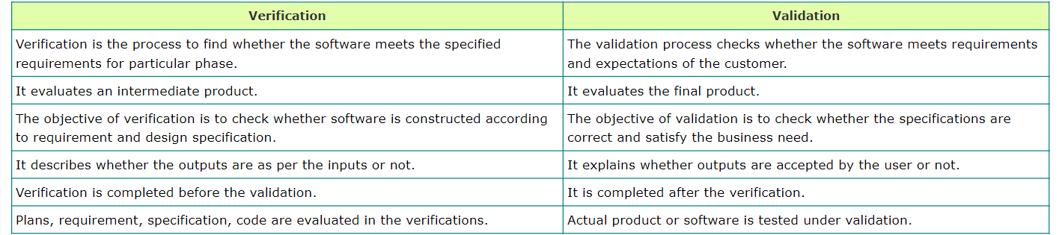

1. **Incremental (Iterative) Model:**

* Basic Requirements
* Customer use the first release
* Modification in the first release
* Useful when staffing is unavailable

**Prototyping Models**

* Allows repeated investigation of the requirements or design
* Reduces risk and uncertainty in the development



1. **RAPID (THROWAWAY) PROTOTYPING:**

Its name refers to the ease and speed with which a prototype can be modified to try different ideas with the user audience and incorporate their feedback.

1. **EVOLUTIONARY PROTOTYPING**

An evolutionary prototype differs from the traditional notion of a software prototype; an evolutionary prototype is a functional piece of software, not just a simulation.

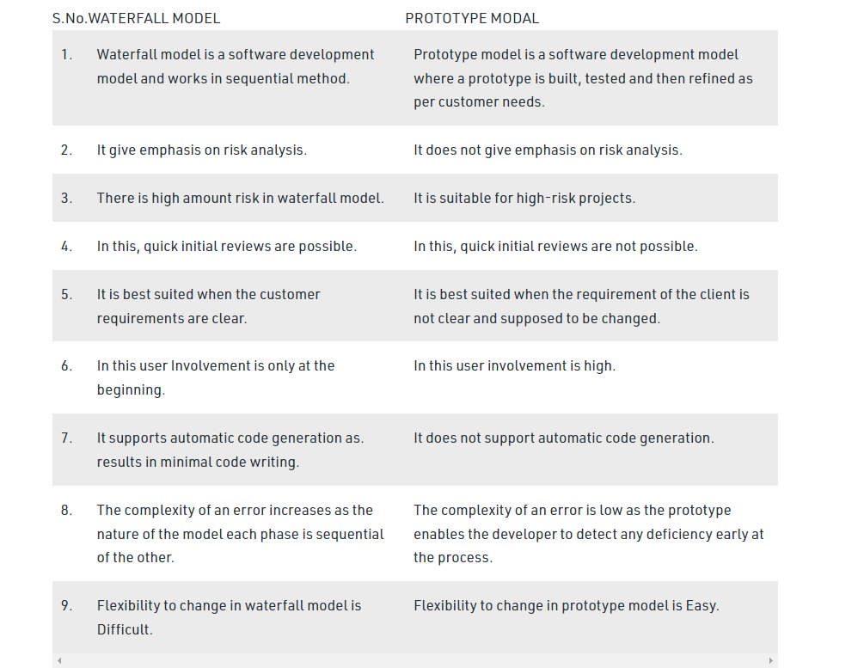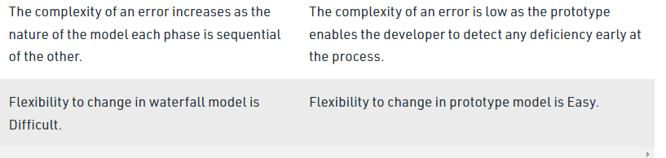

**Spiral Model**

* Combines development activities with risk management to minimize and control risks.
* The model is presented as a spiral in which each iteration is represented by a circuit around four major activities
  + 1. Plan
    2. Determine goals, alternatives and constraints
    3. Evaluate alternatives and risks
    4. Develop and test

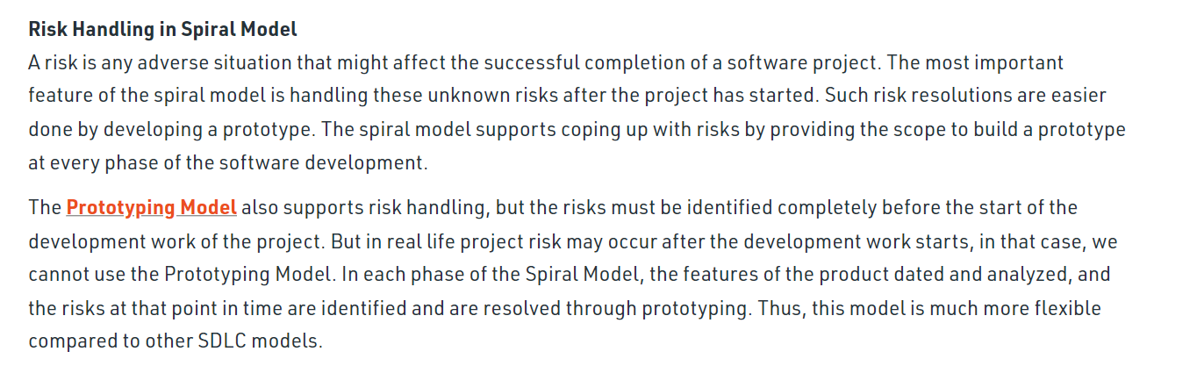

**Unified Process Model**

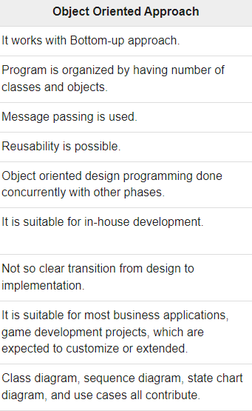



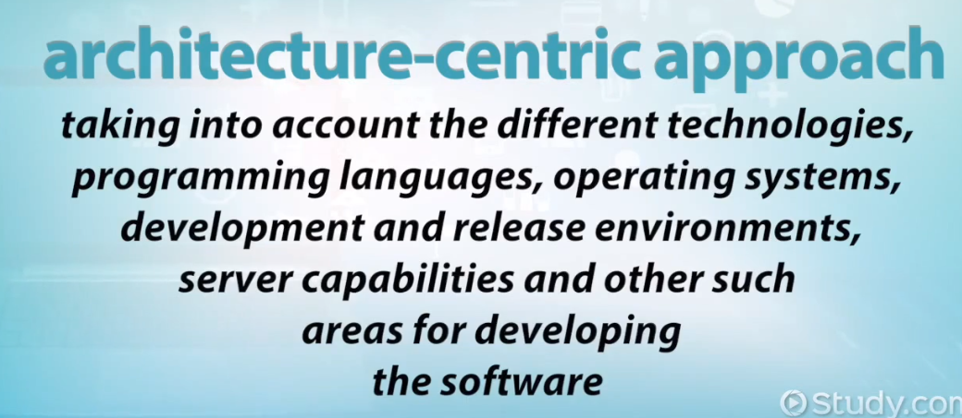

* Object-oriented system development methodology Offered by Rational/IBM, UP developed by Booch, Rumbaugh, and Jacobson
* UP should be tailored to organizational and project needs
* Highly iterative life cycle
* use-case driven (looking through user perspective).
* Risk Focused

**Agile Methods**

* **Agile manifesto**
  + Concentrate on responding to change rather than on creating a plan and then following it
  + Value individuals and interactions over process and tools
  + Prefer to invest time in producing working software rather than in producing comprehensive documentation
  + Focus on customer collaboration rather than contract negotiation





* **Scrum:**
  + A quick, adaptive, and self-organizing development methodology
  + Responds to a current situation as rapidly and positively as possible
  + SCRUM is an agile development method which concentrates specifically on how to manage tasks within a team-based development environment.
  + Scrum believes in empowering the development team and advocates working in small teams (say- 7 to 9 members). It consists of three roles, and their responsibilities are explained as follows
* **Scrum Master**
  + Master is responsible for setting up the team, sprint meeting and removes obstacles to progress
* **Product owner**
  + The Product Owner creates product backlog, prioritizes the backlog and is responsible for the delivery of the functionality at each iteration
  + A product backlog is a list of the new features, changes to existing features, bug fixes, infrastructure changes or other activities that a team may deliver in order to achieve a specific outcome.
* **Scrum Team**
  + Team manages its own work and organizes the work to complete the sprint or cycle
* **Process flow of Scrum Methodologies:**
  + Each iteration of a scrum is known as Sprint
* Product backlog is a list where all details are entered to get the end-product
* During each Sprint, top user stories of Product backlog are selected and turned into Sprint backlog
* Team works on the defined sprint backlog
* Team checks for the daily work
* At the end of the sprint, team delivers product functionality

**RAD Rapid Application Development Model**

* Focuses on short development Life Cycle 60-90 days Project
* Linear Sequential Model
* Multiple Teams working on the modules
* Customer involves throughout the life cycle
* Improve Productivity multiple teams involve
* Not recommended when risk is high
* Sufficient human resources require
* Development team and Client continuously involve in rapid fire activities

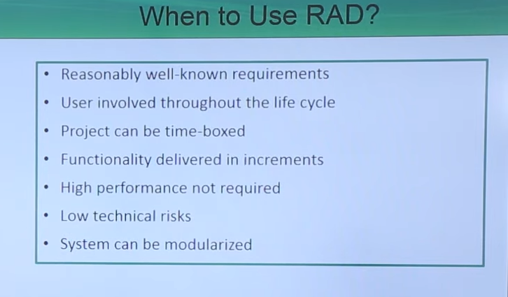

**The Difference between RAD Model and Agile Model**

* Unlike the Waterfall approach, RAD focuses on processes rather than design. RAD uses existing code and proven processes to create new software prototypes.
* This makes the Rapid Application Development model a versatile, adaptable, and time-saving option for software developers and web applications.
* The Rapid Application Development model is best suited in scenarios that require the development of new applications within a span of two to three months.
* However, one must keep in mind that, to develop anything on a RAD platform, the requirements must be well defined.
* Agile recognizes that software projects are fundamentally unpredictable and that there are likely to be changes over the course of the project.
* **Different Stakeholders are:**
  + **Clients:** pay for the software to be developed
  + **Customers=User:** buy the software after it is developed
  + **Users:** use the system
  + **Domain experts:** familiar with the problem that the software must automate example Consulting Banker for bank system
  + **Market Researchers:** conduct surveys to determine future trends and potential customers
  + **Lawyers or auditors:** familiar with government, safety, or legal requirements
  + **Software engineers** or other technology experts

**Data Flow Diagrams (DFDs)**

* A data-flow diagram (DFD) models functionality and the flow of data from one function to another.
* A bubble represents a *process (or data transform)*
* A labelled arrow represents *data flow*, the label describes the data being transferred
* A *data store*: a formal repository or database of information
* Rectangles represent *Information source/sink*: entities that provide input data or receive the output result
* Heritage identifier: to document stepwise refinement
* External Entity 🡪 Noun
* Data Flow 🡪 Names of data
* Process 🡪 verb phrase

1. a system names
2. a subsystem names

* Data Store 🡪 Noun

**Level 0 DFD-Contextual Diagram**

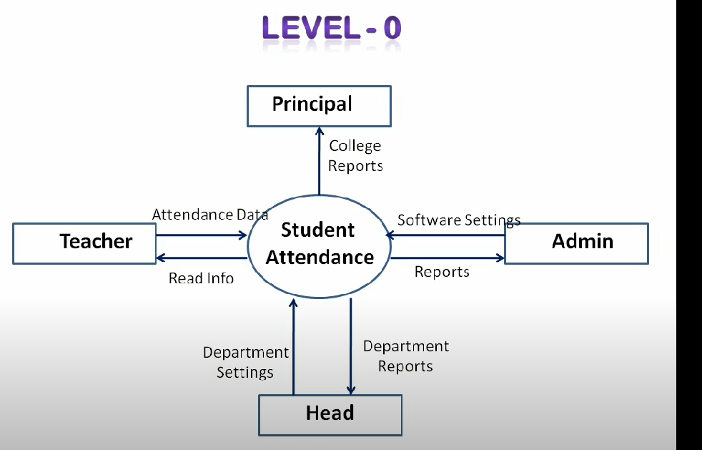

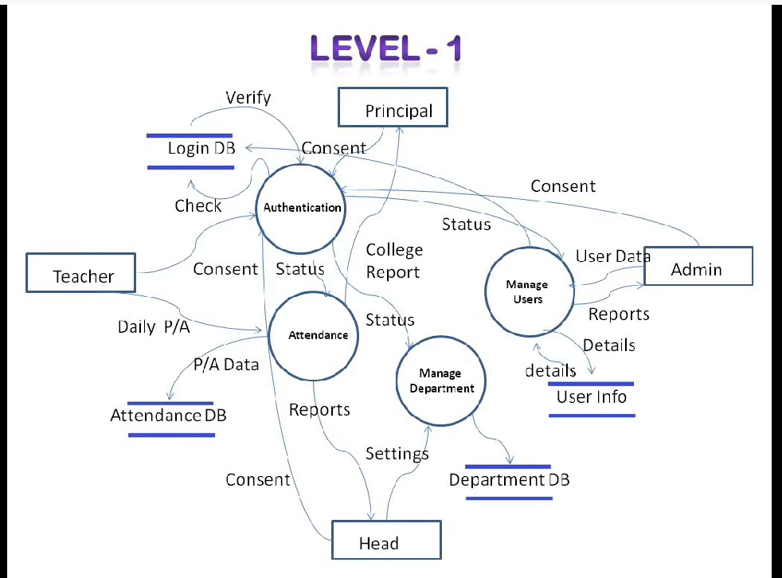

**Non-functional requirements:** These are basically the quality constraints that the system must satisfy according to the project contract. The priority or extent to which these factors are implemented varies from one project to other. They are also called non-behavioral requirements.

|  |  |
| --- | --- |
| A functional requirement defines a system or its component. | A non-functional requirement defines  the quality attribute of a software system. |
| It specifies “What should the software system do?” | It places constraints on “How should the  software system fulfills the functional  requirements?” |
| Functional requirement is specified by User. | Non-functional requirement is specified by  technical peoples e.g., Architect,  Technical leaders and software developers. |
| It is mandatory. | It is not mandatory. |
| It is captured in use case. | It is captured as a quality attribute. |
| Defined at a component level. | Applied to a system as a whole. |
| Helps you verify the functionality of the software. | Helps you to verify the performance of the software. |
| Functional Testing like System, Integration, End to End, API testing, etc. are done. | Non-Functional Testing like Performance,  Stress, Usability, Security testing, etc are done. |
| Usually easy to define. | Usually more difficult to define. |
| **Example1)** Authentication of user whenever he/she logs into the system. **2)** System shutdown in case of a cyber attack. **3)** A Verification email is sent to user whenever he/she registers for the first time on some software system. | **Example1)** Emails should be sent with a latency of  no greater than 12 hours from such an activity. **2)** The processing of each request should be done  within 10 seconds **3)** The site should load in 3 seconds when the  number of simultaneous users are > 10000 |



**Use Case Diagram**

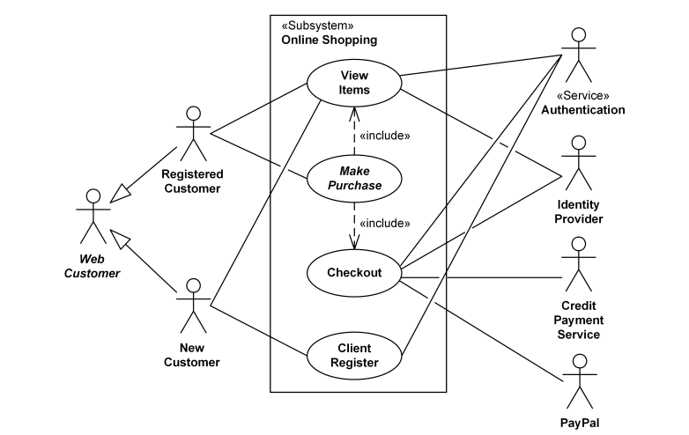

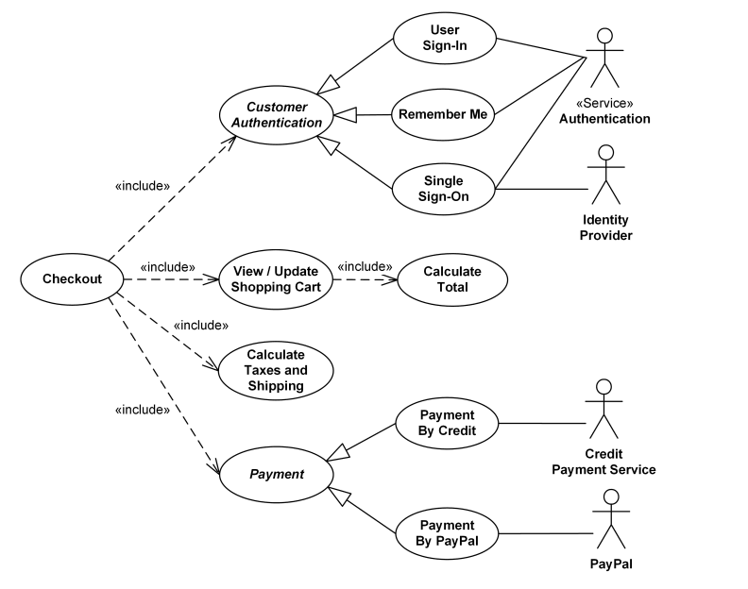

**Entity-Relationship Diagram**

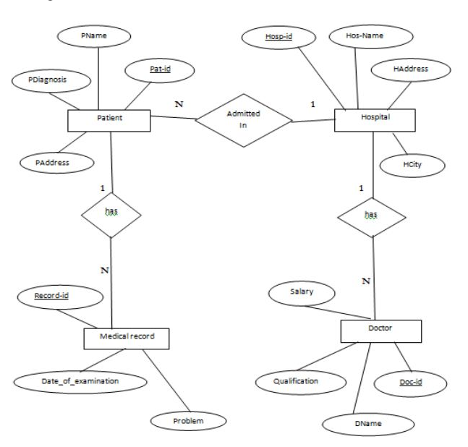

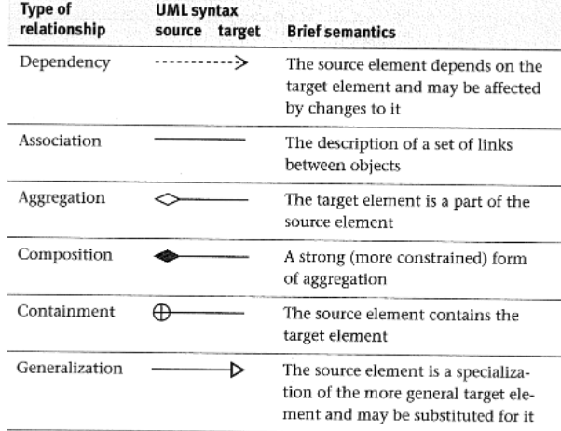

**Class Diagram**

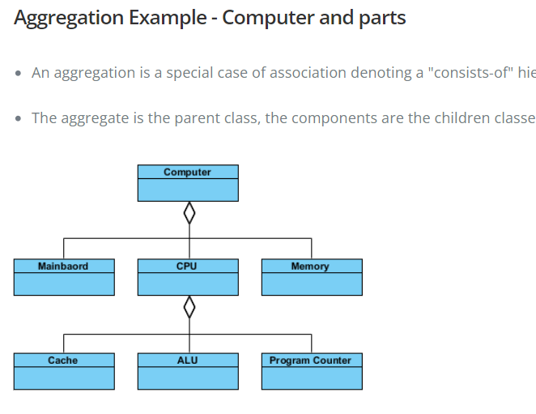

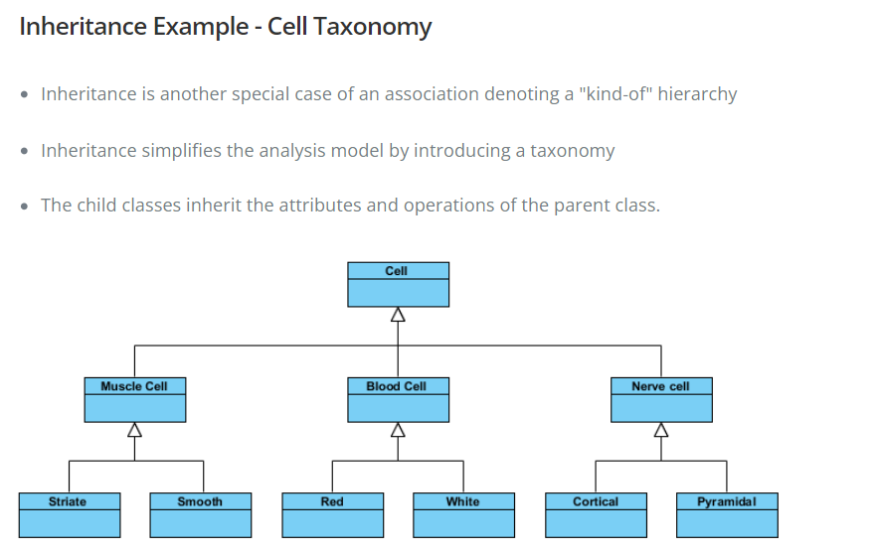

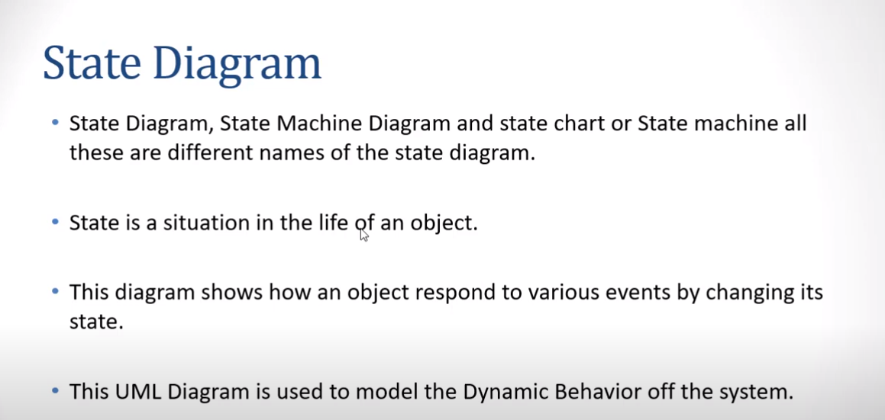

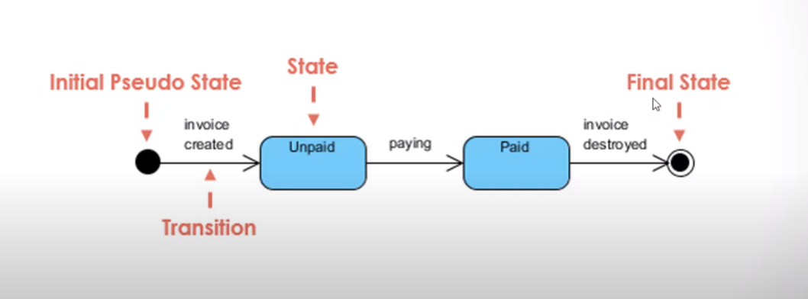

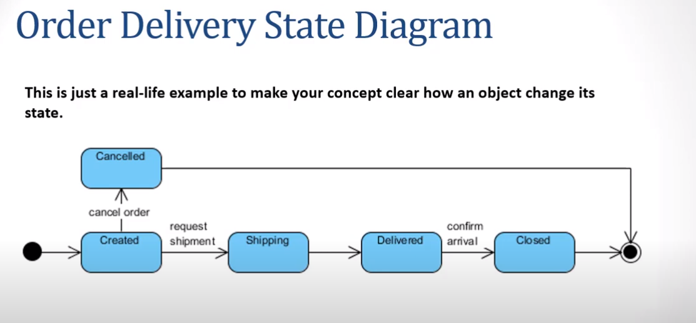

**Activity on Arrow(AOA)**

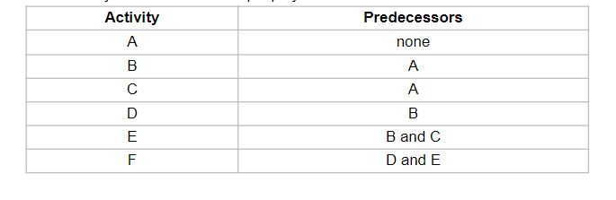

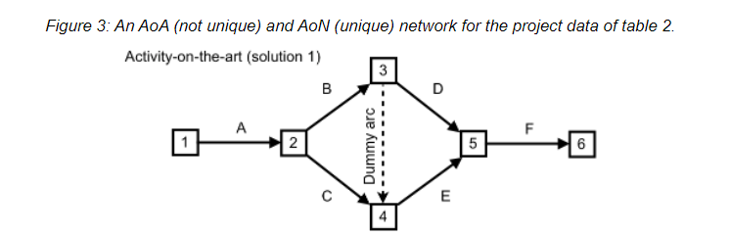

**Activity on Node (AON)**



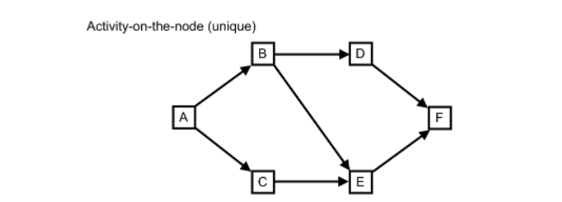

**Estimating Completion Critical Path Method**

* Earliest Finish =Earliest Start + duration
* Latest Start=Latest Finish-Duration
* Slack time = Delayed time
  + Formulae=Latest Finish-Earliest Finish
* Critical path: the slack at every activity is zero
  + can be more than one in a project schedule

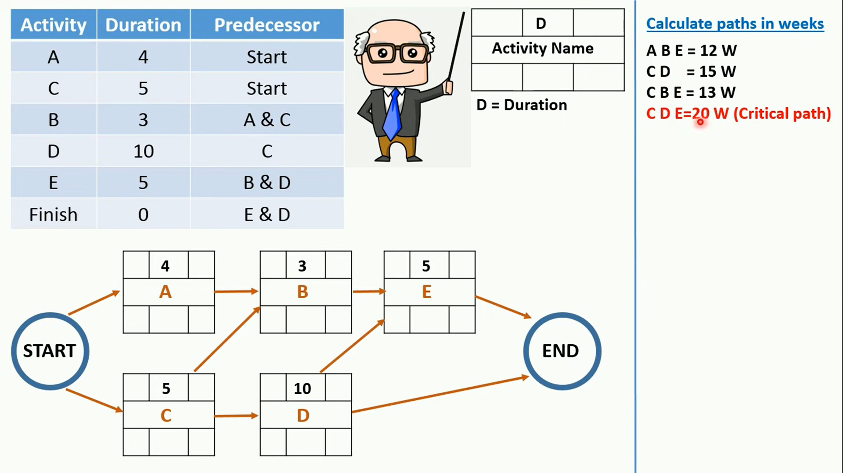

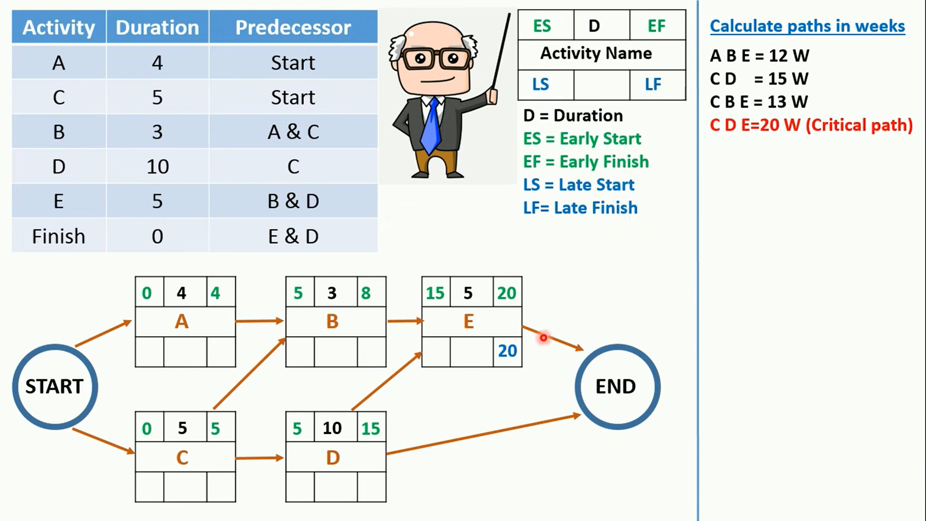

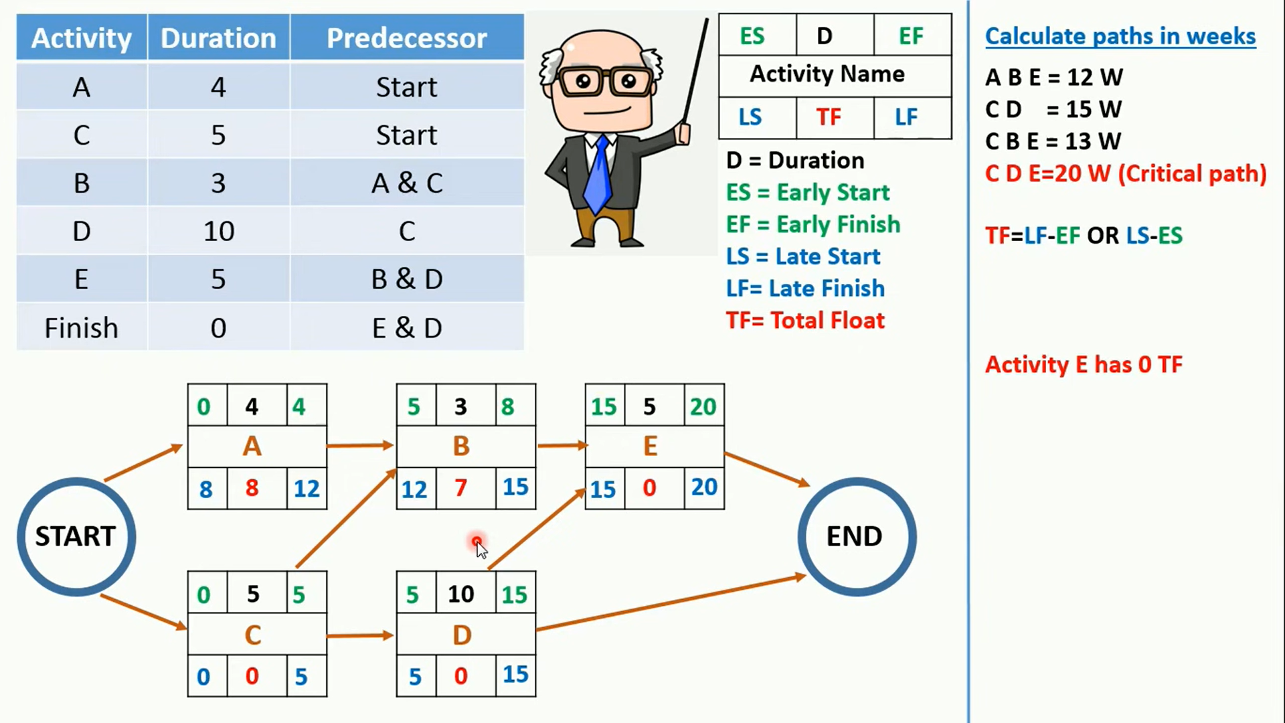

**Modeling Maintenance Effort: Belady and Lehman**

* ***M* = *p* + *Kc-d***
  + ***M:*** total maintenance effort
  + ***p*:** productive effort
  + ***c*:** complexity
  + ***d*:** degree of familiarity
  + ***K*:** empirical constant

**Modeling Maintenance Effort: COCOMO II (Constructive Cost Model)**

* **Size = *ASLOC* (*AA* + *SU* + 0.4*DM* + 0.3*CM* + 0.3*IM*)/100**
  + ***ASLOC*:** number of source lines of code to be adapted
  + ***AA*:** assessment and assimilation effort
  + ***SU*:** amount of software understanding required
  + ***DM*:** percentage of design to be modified
  + ***CM*:** percentage of code to be modified
  + ***IM*:** percentage of external code to be integrated

**Example**

Suppose that we need to perform a maintenance task. We estimate that the task needs 10,000 Lines of Code to be adapted. Let us assume that the value for design modification is 10%, the value for code modification is 20%, and the value for code integration is 40%. Suppose that AA was 4%, SU was 30%. What would be the COCOMO II based estimate of size for the maintenance task?

**Sol.**

Let Adaptation Adjustment Factor (AAF) = (.4DM +.3CM +.3IM)

Size = ASLOC (AA + SU + AAF)/100

AAF = (0.4 x 0.1) + (0.3 x 0.2) + (0.3 x 0.4) = 0.22

Size = 10000(0.04 + 0.3 + 0.22)/100 = 56

**Coupling**

* Two modules are **tightly coupled** when they depend a great deal on each other
* **Loosely coupled** modules have some dependence, but their interconnections are weak
* **Uncoupled** modules have no interconnections at all; they are completely unrelated

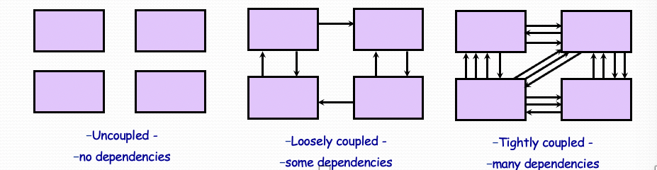

**Types of Coupling**

* **Content coupling**

One component modifies an internal data item of another component, a component (e.g., B) branches into another component (e.g., D)

* **Common coupling**

Dependency due to common data. Tracing back to all components that access those data to evaluate the effect of the change

* **Control -coupling**

One component passes parameters to control the activity of another component. The controlled component cannot function without direction from the controlling component. Make each component perform only one function

* **Stamp Coupling**: Stamp coupling, or data structure coupling, occurs when modules share a composite data structure and use only a part of it, possibly different parts.
* **Stamp coupling** occurs when complex data structures are passed between modules

Stamp coupling represents a more complex interface between modules, because the modules have to agree on the data’s format and organization

* **Data Coupling**: Data coupling occurs when methods share data, regularly through parameters. Data coupling is better than stamp coupling, because the module takes exactly what it needs, without the need of it knowing the structure of a particular data structure.
  + Data coupling is simpler and less likely to be affected by changes in data representation
  + Only data value is passed from one component to another
  + Easiest to trace data and make changes

High coupling is **NOT** desired

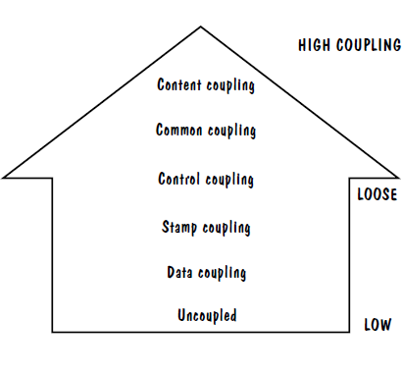

**Cohesion** refers to the dependence within and among a module’s internal elements (e.g., data, functions, internal modules)

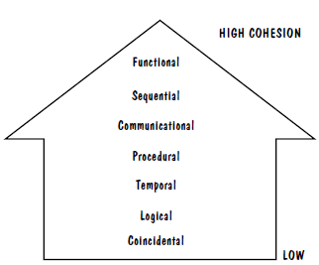

**Low** Cohesion is not desired

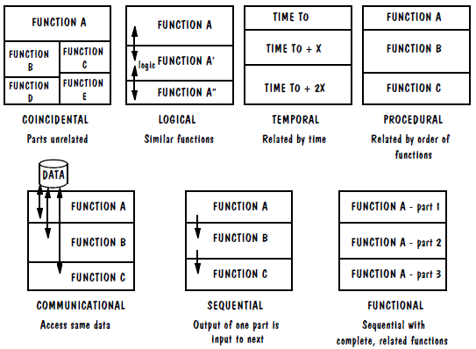

**Some popular design methods:**

* Functional decomposition

Student Registration System

Data Entry Validation

Transaction Verification

Report Generation

Student Data Validation

Course Data Validation

Data Updation

Transaction Checks

Addition Modules

Deletion Module

* Feature-oriented decomposition

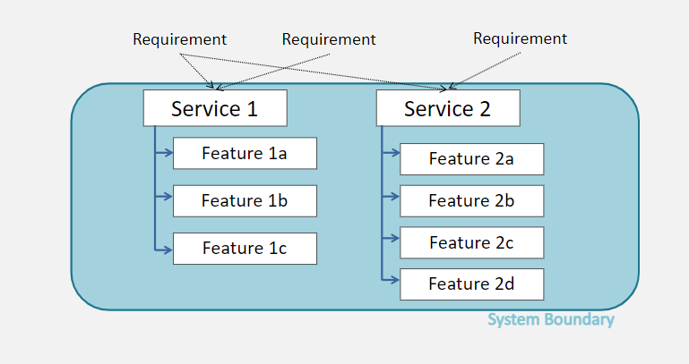

* Data-oriented decomposition

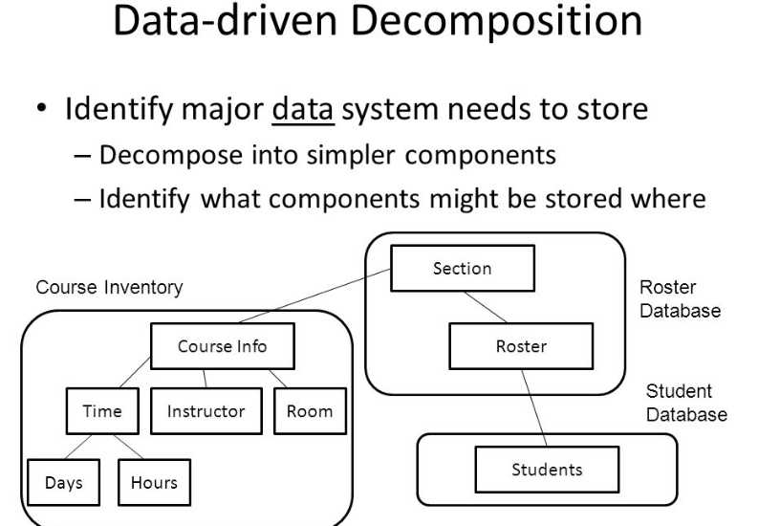

* Process-oriented decomposition

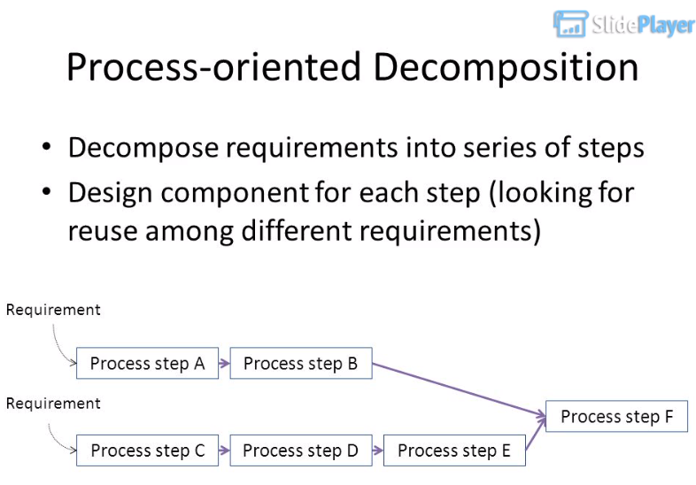

* Object-oriented design

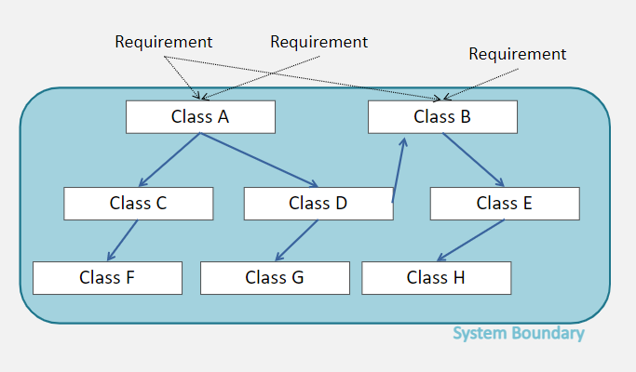

* Event –oriented Decomposition

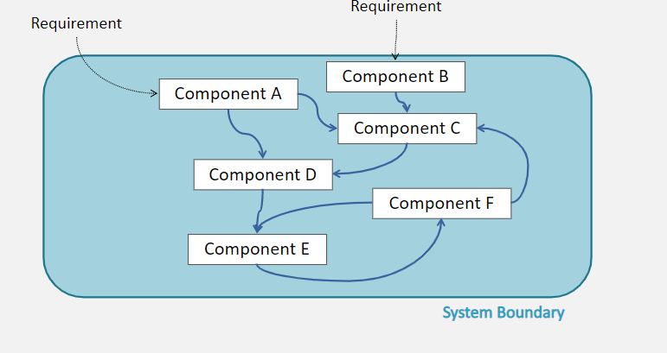

**Architectural Styles and Strategies**

1. **Pipe-and-Filter**

The system has

* 1. Streams of data (pipe) for input and output
  2. Transformation of the data (filter)
  3. The designer can understand the entire system's effect on input and output as the composition of the filters
  4. The filters can be reused easily on other systems
  5. System evolution is simple
  6. Allow concurrent execution of filters

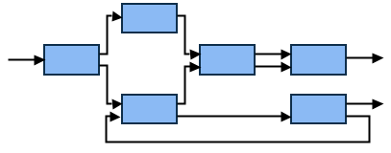 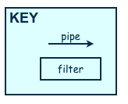

1. **Client-Server**

Two types of components:

* 1. Server components offer services
  2. Clients access them using a request/reply protocol
  3. Client may send the server an executable function, called a callback

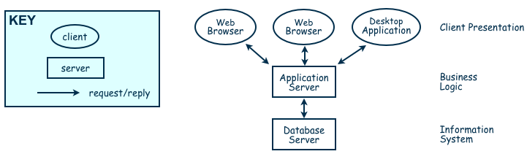

1. **Peer-to-Peer**

Each component acts as its own process and acts as both a client and a server to other peer components.

Any component can initiate a request to any other peer component.

* **Characteristics**
  + Scale up well
  + Increased system capabilities
  + Highly tolerant of failures
* **When NOT to use:**
  + When file contents change frequently (e.g., prices)
  + When sharing speed has importance (e.g., large files are needed quickly)
  + File quality is critical
  + When trust between peers is required (e.g., the content is protected)

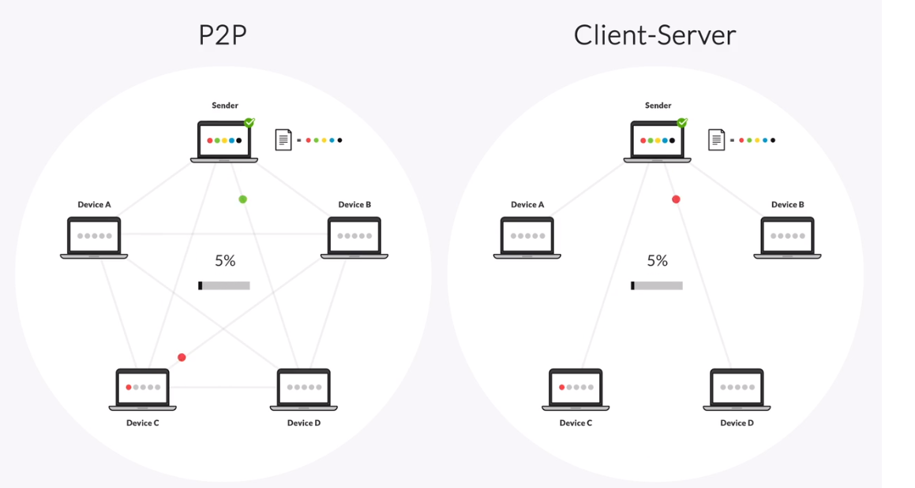

1. **Publish-Subscribe**

* interact by broadcasting and reacting to events Components
* Component expresses interest in an event by subscribing to it
* **Characteristics**
  + Strong support for evolution and customization
  + Easy to reuse components in other event-driven systems
  + Need shared repository for components to share persistent data
  + Difficult to test

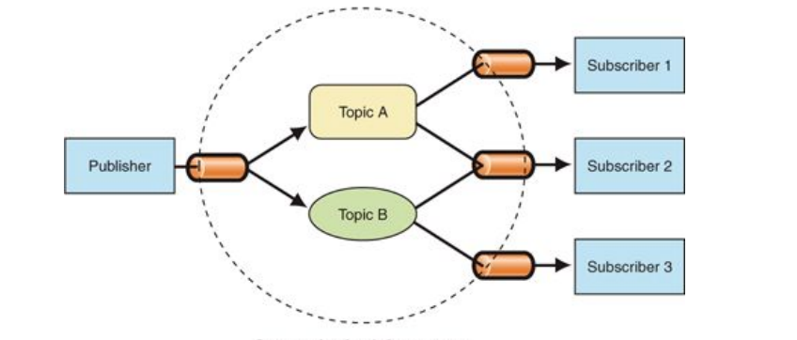

1. **Repositories**

* Two components
  1. A central data stores
  2. A collection of components that operate on it to store, retrieve, and update information (data accessors)
* The challenge is deciding how the components will interact
* A traditional database: transactions trigger process execution
* A blackboard: the central store controls the triggering process
* Knowledge sources: information about the current state of the system’s execution that triggers the execution of individual data accessors

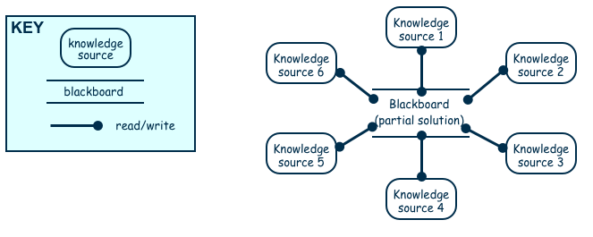

1. **Layering**

* Layers are hierarchical
* Each layer provides service to the one outside it and acts as a client to the layer inside it
* Layer bridging: allowing a layer to access the services of layers below its lower neighbor
* The design includes protocols
* High levels of abstraction
* Relatively easy to add and modify a layer
* Not always easy to structure system layers
* System performance may suffer from the extra coordination among layers

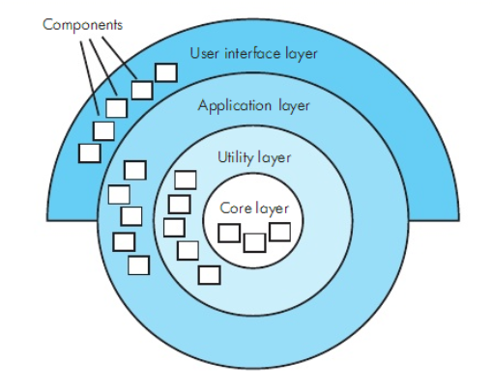

**Combination of Publish-Subscribe, Client-Server, Layering, Repository**

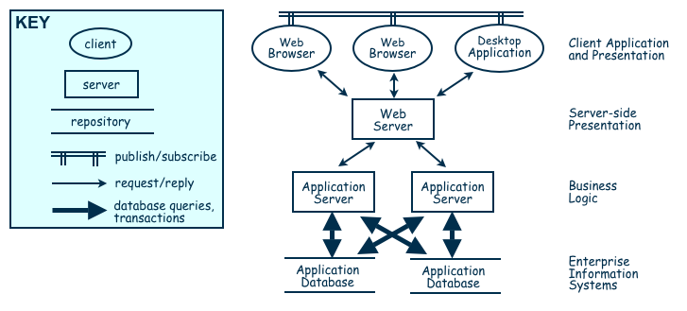

* **Immunity:** ability to thwart an attempted attack
* **Resilience:** ability to recover quickly and easily from an attack
* **Fault recovery:** handling fault immediately to limit damage
* A system is **robust** if it includes mechanisms for accommodating or recovering from problems in the environment or in another unit

**FLOW Graph**

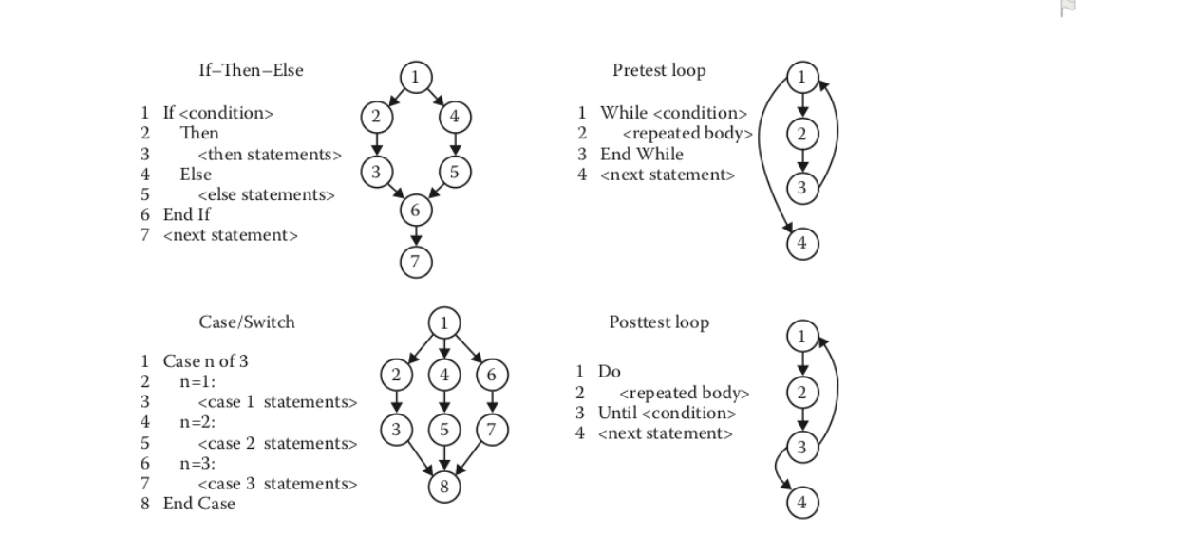

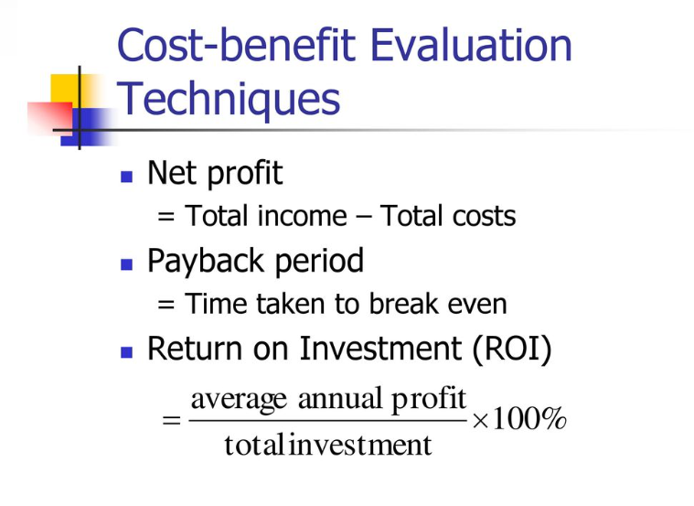

**Testing Types**

**The Black Box** Test is a test that only considers the external behavior of the system; the internal workings of the software are not taken into account.

**White Box Test** is a method used to test a software taking into consideration its internal functioning. It is carried out by testers.

 

**Edges and Nodes Method**

**Cyclomatic Complexity = E – N + 2 = 9 – 9 + 2 = 2**

**Branch Method (If, for, while)**

**C=B+1=1+1=2**

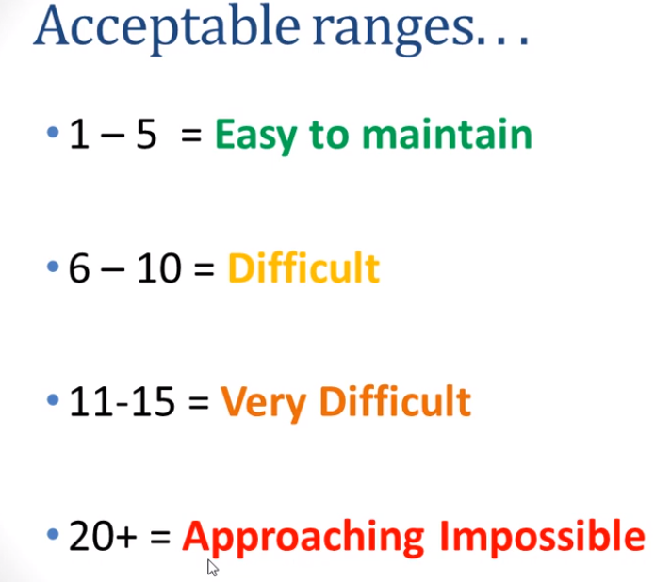

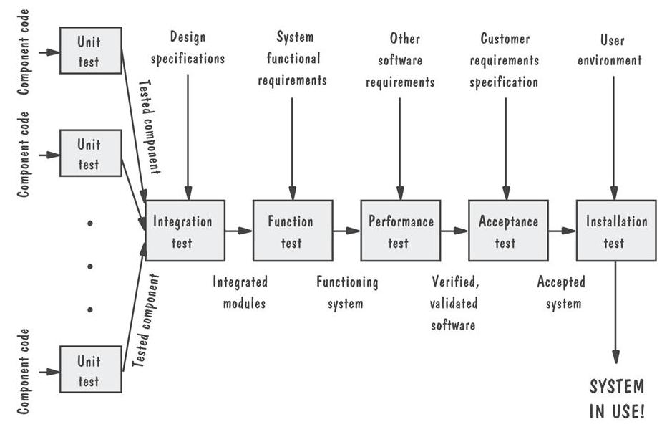

**Statement Coverage (SC)**:

To calculate Statement  Coverage, find out the shortest number of paths following

which all the nodes will be covered. Here by traversing through path 1A-2C-3D-E-4G-5H all

the nodes are covered. So by traveling through only one path all the nodes 12345 are covered,

so the Statement coverage in this case is 1.

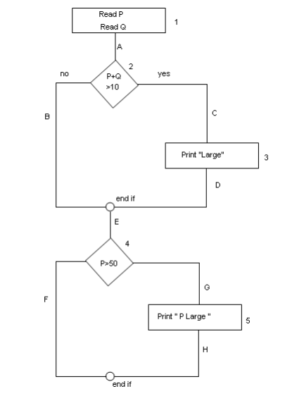

To calculate **Branch Coverage**, find out the minimum number of paths which will

ensure covering of all the edges. In this case there is no single path which will ensure coverage of  all the edges  at one go.  By following paths 1A-2C-3D-E-4G-5H, maximum  numbers of edges (A, C, D, E, G and H) are covered but edges B and F are left. To covers these edges we can follow  1A-2B-E-4F. By the combining the above two paths we can ensure of traveling

through all the paths. Hence Branch Coverage is 2. The aim is to cover all possible true/false

decisions.



**Path Coverage (PC)**:

Path Coverage ensures covering of all the paths from start to end.

All possible paths are-

1A-2B-E-4F

1A-2B-E-4G-5H

1A-2C-3D-E-4G-5H

1A-2C-3D-E-4F

So path coverage is 4.

Thus for the above example SC=1, BC=2 and PC=4.

